物料消耗查询接口

文档作者: 张文

创建日期: 2022-10-13

更新日期:

文档编号:

当前版本: V1.1

1. **Title, Subject, Last Updated Date, Reference Number**, **and** **Version** are marked by a Word Bookmark so that they can be easily reproduced in the header and footer of documents. When you change any of these values, be careful not to accidentally delete the bookmark. **You can make bookmarks visible by selecting Tools->Options…View and checking the Bookmarks option in the Show region.**

**审批签字:**

|  |  |
| --- | --- |
|  |  |
|  |  |

1. To add additional approval lines, press [Tab] from the last cell in the table above.
2. You can delete any elements of this cover page that you do not need for your document. For example, Copy Number is only required if this is a controlled document and you need to track each copy that you distribute.

## 文档控制

**变更记录**

3

| 日期 | 作者 | 版本 | 变更说明 |
| --- | --- | --- | --- |
|  |  |  |  |
| 2022.10.20 | 张文 | v.1.1 |  |
|  |  |  |  |
|  |  |  |  |
|  |  |  |  |

**审阅**

| 姓名 | 职位 |
| --- | --- |
|  |  |
|  |  |
|  |  |
|  |  |
|  |  |

**分发**

| 拷贝编号 | 姓名 | 位置/岗位 |
| --- | --- | --- |
|  |  |  |
|  |  |  |
| 2 |  |  |
| 3 |  |  |
| 4 |  |  |

1. The copy numbers referenced above should be written into the **Copy Number** space on the cover of each distributed copy. If the document is not controlled, you can delete this table, the Note To Holders, and the **Copy Number** label from the cover page.

目录

文档控制 ii

基本业务需求 4

主要特性 4

数据源描述 4

物料消耗数据接口 5

遗留和解决问题 6

未解决问题 6

已解决问题 6

1. To update the table of contents, put the cursor anywhere in the table and press [F9]. To change the number of levels displayed, select the menu option Insert‑>Index and Tables, make sure the Table of Contents tab is active, and change the Number of Levels to a new value.

### 基本业务需求

需求说明：

物料消耗查询接口：业务人员通过工厂代码、物料编码、开始日期、结束日期询问SAP，SAP返回物料消耗数据。

### 主要特性

】

### 数据源描述

| 数据源描述 | 现有/新增 | 选择 | 插入 | 更新 | 删除 |
| --- | --- | --- | --- | --- | --- |
|  |  |  |  |  |  |
|  |  |  |  |  |  |
|  |  |  |  |  |  |
|  |  |  |  |  |  |
|  |  |  |  |  |  |
|  |  |  |  |  |  |
|  |  |  |  |  |  |
|  |  |  |  |  |  |
|  |  |  |  |  |  |
|  |  |  |  |  |  |
|  |  |  |  |  |  |
|  |  |  |  |  |  |

### 物料消耗数据接口

|  |  |
| --- | --- |
| **函数名称** | 物料消耗数据 |
| **函数名** |  |
| **业务模块** | MM |
| **使用对象** | 接口 |
| **频率** | 实时调用 |

数据来源

数据表：MSEG、MKPF

SAP发布接口字段

|  |  |  |  |  |  |
| --- | --- | --- | --- | --- | --- |
| **SAP字段** | **字段描述** | **参考字段** | **数据类型** | **长度** | **是否必传** |
| WERKS | 工厂代码 | MSEG- WERKS | CHAR | 4 | Y |
| MATNR | 物料编码 | MSEG- MATNR | CHAR | 18 | Y |
| BUDAT | 开始日期 | MKPF- BUDAT | DATS | 8 | Y |
| BUDAT | 结束日期 | MKPF- BUDAT | DATS | 8 | Y |

SAP反馈接口字段

|  |  |  |  |  |  |
| --- | --- | --- | --- | --- | --- |
| **SAP字段** | **字段描述** | **参考字段** | **数据类型** | **长度** | **是否必传** |
| BUDAT | 过账日期 | MKPF- BUDAT | DATS | 8 | Y |
| MATNR | 物料编码 | MSEG- MATNR | CHAR | 18 | Y |
| MENGE | 数量 | MSEG- MENGE | QUAN | 13 | Y |
| MEINS | 基本计量单位 | MSEG- MEINS | UNIT | 3 | Y |

接口取数逻辑：

1. 解析业务系统传输字段，并且参照对照表赋值给对应变量；
2. 根据工厂代码、物料编号、开始日期、结束日期获取物料对应的消耗数量，其中消耗物料数量取MSEG表中物料编码MATNR在该时间段中移动类型BWART为201、202、261、262的数量，根据“借/贷标识（D/C）” SHKZG显示明细数量，如果是贷方（H）对应的物料数量为负数，借方（S）对应的物料数量为正数。

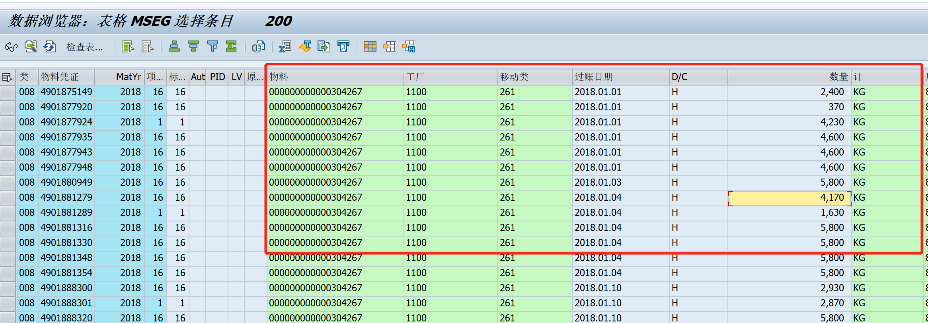

例如：返回物料消耗数据：

过账日期 物料编码 数量 基本单位

2018.01.01 204267 2400 kg

2018.01.01 204267 370 kg

2018.01.01 204267 4230 kg

2018.01.01 204267 -1630 kg

2018.01.02 204267 1200 kg

## 遗留和解决问题

1. Add open issues that you identify while writing or reviewing this document to the open issues section. As you resolve issues, move them to the closed issues section and keep the issue ID the same. Include an explanation of the resolution.  
     
   When this deliverable is complete, any open issues should be transferred to the project- or process-level Risk and Issue Log (PJM.CR.040) and managed using a project level Risk and Issue Form (PJM.CR.040). In addition, the open items should remain in the open issues section of this deliverable, but flagged in the resolution column as being transferred.

### 未解决问题

| 标识号 | 问题 | 解决方案 | 负责人 | 目标解决日期 | 影响日期 |
| --- | --- | --- | --- | --- | --- |
|  |  |  |  |  |  |
|  |  |  |  |  |  |
|  |  |  |  |  |  |
|  |  |  |  |  |  |
|  |  |  |  |  |  |

### 已解决问题

| 标识号 | 问题 | 解决方案 | 负责人 | 目标解决日期 | 影响日期 |
| --- | --- | --- | --- | --- | --- |
|  |  |  |  |  |  |
|  |  |  |  |  |  |
|  |  |  |  |  |  |
|  |  |  |  |  |  |
|  |  |  |  |  |  |